Vision-Enhanced Expressive AI Companion for Dementia Care

1. Project Overview
This project extends an existing conversational plush companion by incorporating vision-based emotion detection and expressive physical movement. The system is designed as a stationary affective AI companion that responds to user emotional cues through intuitive, non-verbal interaction suitable for dementia care environments.
- Builds on existing audio-based companion system
- Focus on expressive based interaction
- Emphasis on hardware procurement and system integration

2. Main Features and Focus Areas
Emotion Detection Using Computer Vision
- Front-facing camera
- Detect coarse emotional cues (calm / neutral / distressed)
- Used for affective responsiveness
Expressive Physical Movement (Ideas)
- Primary communication modality
- Head rotation and tilt to orient toward user using human tracking
- Simple body gestures for attentiveness and reassurance
- Optional tail-like structures for expressive motion

Subsequent Integration
Conversational interaction will be integrated after expressive behaviour is established, building on the existing system.

Secondary Focus (If Time Allows)
Additional interaction modalities may be explored to enhance engagement.
Tactile Interaction
- Touch-sensitive body regions
- Physical interaction as an input modality
- Touch used to trigger or modulate expressive behaviour
3. Design Inspiration and Form Factor

3.1 Therapeutic and Expressive Precedents
Therapeutic robots such as PARO Therapeutic Robot demonstrate the importance of tactile engagement and physical presence, while expressive companions such as LivingAI EMO and Qoobo highlight how motion-based expression enhances perceived personality and emotional connection. These systems serve as design inspiration for an expressive companion.
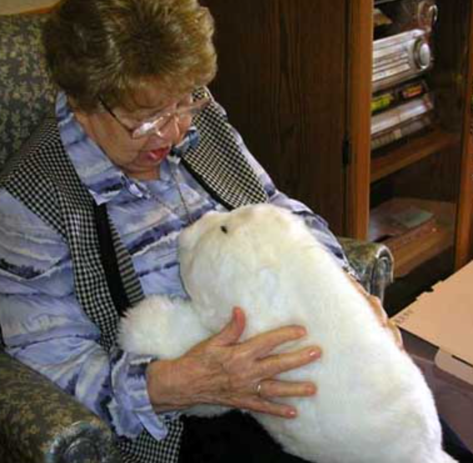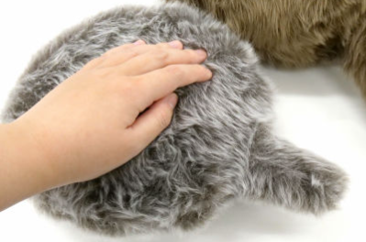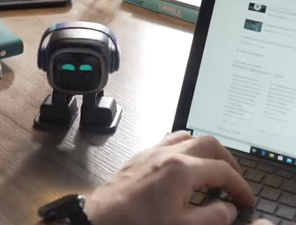

3.2 Singapore-Themed Physical Design
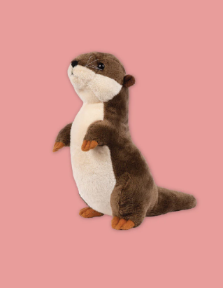
To create a familiar and approachable companion, the physical form may draw inspiration from:
A Singapore otter, associated with friendliness and playfulness
NUS Linus, a recognisable campus mascot | 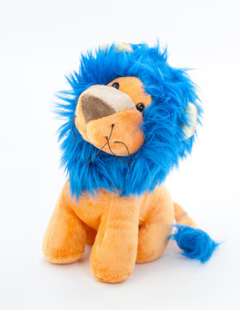

The internal structure will consist of a custom 3D-printed skeleton designed to house a rotating head, expressive elements, sensors, and embedded electronics, while remaining compatible with a soft outer shell suitable for handling.

3.3 Expressive Design Elements
Expressive communication will rely on:
- Head orientation and tilt
- Subtle body or tail-like movements (Similar to pets)
- Movement patterns that vary based on perceived emotional context
These elements are designed to be gentle, interpretable, and non-overstimulating, aligning with therapeutic interaction principles.
4. Rough Procurement List and Technical Rationale (TBC)
Total Budget: $2500
Current Total for initial procurement: $1031.91
Component Category | Options | Cost | Purpose / Rationale
Compute Platform | Jetson Orin Nano Super 8GB Developer Kit | $510 | Required for real-time computer vision and emotion inference
Camera | RGB camera | $26.48 | Enough resolution to enable emotion detection and face tracking for vision-driven expressive behaviour
Microphone | Microphone array (directional audio) | $157.44 | Supports clear conversational interaction from all directions
AI Voice Module | AI Voice recognition module | $33.48 | Alternative ai microphone to test
Speaker | Speaker module | $21.54 | Provides verbal reassurance and audio feedback; integrates with existing system
Actuation | Quiet motors (Brushless BLDC)  + Driver  (Will test with my own motors first) | - | Enables head movement and expressive gestures; core to non-verbal emotional communication.
Tactile Sensors | Pressure touch sensors | $16.80 | Detects user touch; enables tactile interaction as an input modality
Mechanical & Thermal | 3D-printing filament (PETG/TPU)  (1 PETG & 1 TPU) | $50.70 | Custom 3d printed internal structure. TPU can provide the soft outer structure and PETG for the rigid structure.

